CSS is the language we use to style a Web page.

What is CSS?

* CSS stands for Cascading Style Sheets
* CSS describes how HTML elements are to be displayed on screen, paper, or in other media
* CSS saves a lot of work. It can control the layout of multiple web pages all at once
* External stylesheets are stored in CSS files

## Why Use CSS?

CSS is used to define styles for your web pages, including the design, layout and variations in display for different devices and screen sizes.

## CSS Solved a Big Problem

HTML was NEVER intended to contain tags for formatting a web page!

HTML was created to describe the content of a web page, like:

<h1>This is a heading</h1>

<p>This is a paragraph.</p>

When tags like <font>, and color attributes were added to the HTML 3.2 specification, it started a nightmare for web developers. Development of large websites, where fonts and color information were added to every single page, became a long and expensive process.

To solve this problem, the World Wide Web Consortium (W3C) created CSS.

CSS removed the style formatting from the HTML page!

# **CSS Syntax**

A CSS rule consists of a selector and a declaration block.

## CSS Syntax

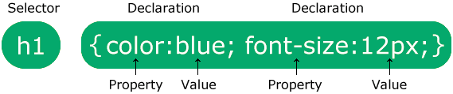

The selector points to the HTML element you want to style.

The declaration block contains one or more declarations separated by semicolons.

Each declaration includes a CSS property name and a value, separated by a colon.

Multiple CSS declarations are separated with semicolons, and declaration blocks are surrounded by curly braces.

#### **Example Explained**

* p is a selector in CSS (it points to the HTML element you want to style: <p>).
* color is a property, and red is the property value
* text-align is a property, and center is the property value

# **CSS Selectors**

A CSS selector selects the HTML element(s) you want to style.

CSS Selectors

CSS selectors are used to "find" (or select) the HTML elements you want to style.

We can divide CSS selectors into five categories:

* Simple selectors (select elements based on name, id, class)
* [Combinator selectors](https://www.w3schools.com/css/css_combinators.asp) (select elements based on a specific relationship between them)
* [Pseudo-class selectors](https://www.w3schools.com/css/css_pseudo_classes.asp) (select elements based on a certain state)
* [Pseudo-elements selectors](https://www.w3schools.com/css/css_pseudo_elements.asp) (select and style a part of an element)
* [Attribute selectors](https://www.w3schools.com/css/css_attribute_selectors.asp) (select elements based on an attribute or attribute value)

This page will explain the most basic CSS selectors.

The CSS element Selector

The element selector selects HTML elements based on the element name.

## The CSS id Selector

The id selector uses the id attribute of an HTML element to select a specific element.

The id of an element is unique within a page, so the id selector is used to select one unique element!

To select an element with a specific id, write a hash (#) character, followed by the id of the element.

**Note:** An id name cannot start with a number!

## The CSS class Selector

The class selector selects HTML elements with a specific class attribute.

To select elements with a specific class, write a period (.) character, followed by the class name.

You can also specify that only specific HTML elements should be affected by a class.

HTML elements can also refer to more than one class.

**Note:** A class name cannot start with a number!

## The CSS Universal Selector

The universal selector (*) selects all HTML elements on the page.

## The CSS Grouping Selector

The grouping selector selects all the HTML elements with the same style definitions.

It will be better to group the selectors, to minimize the code.

To group selectors, separate each selector with a comma.

## All CSS Simple Selectors

|  |  |  |
| --- | --- | --- |
| **Selector** | **Example** | **Example description** |
| [#*id*](https://www.w3schools.com/cssref/sel_id.php) | #firstname | Selects the element with id="firstname" |
| [.*class*](https://www.w3schools.com/cssref/sel_class.php) | .intro | Selects all elements with class="intro" |
| [*](https://www.w3schools.com/cssref/sel_all.php) | * | Selects all elements |
| [*element*](https://www.w3schools.com/cssref/sel_element.php) | p | Selects all <p> elements |
| [*element,element,..*](https://www.w3schools.com/cssref/sel_element_comma.php) | div, p | Selects all <div> elements and all <p> elements |

# **How To Add CSS**

Three Ways to Insert CSS

There are three ways of inserting a style sheet:

* External CSS
* Internal CSS
* Inline CSS

External CSS

With an external style sheet, you can change the look of an entire website by changing just one file!

Each HTML page must include a reference to the external style sheet file inside the <link> element, inside the head section.

An external style sheet can be written in any text editor, and must be saved with a .css extension.

The external .css file should not contain any HTML tags.

**Note:** Do not add a space between the property value (20) and the unit (px):  
Incorrect (space): margin-left: 20 px;  
Correct (no space): margin-left: 20px;

## Internal CSS

An internal style sheet may be used if one single HTML page has a unique style.

The internal style is defined inside the <style> element, inside the head section.

## Inline CSS

An inline style may be used to apply a unique style for a single element.

To use inline styles, add the style attribute to the relevant element. The style attribute can contain any CSS property.

**Tip:** An inline style loses many of the advantages of a style sheet (by mixing content with presentation). Use this method sparingly.

## Multiple Style Sheets

If some properties have been defined for the same selector (element) in different style sheets, the value from the last read style sheet will be used.

Cascading Order

What style will be used when there is more than one style specified for an HTML element?

All the styles in a page will "cascade" into a new "virtual" style sheet by the following rules, where number one has the highest priority:

1. Inline style (inside an HTML element)
2. External and internal style sheets (in the head section)
3. Browser default

So, an inline style has the highest priority, and will override external and internal styles and browser defaults.

# **CSS Comments**

Comments are used to explain the code, and may help when you edit the source code at a later date.

Comments are ignored by browsers.

A CSS comment is placed inside the <style> element, and starts with /* and ends with */

# **CSS Colors**

Colors are specified using predefined color names, or RGB, HEX, HSL, RGBA, HSLA values.

## CSS Background Color

## CSS Text Color

## CSS Border Color

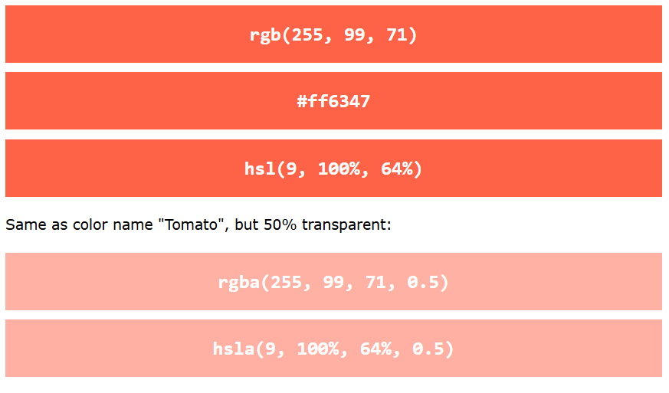

## RGB Value

In CSS, a color can be specified as an RGB value, using this formula:

**rgb(red, green, blue)**

Each parameter (red, green, and blue) defines the intensity of the color between 0 and 255.

For example, rgb(255, 0, 0) is displayed as red, because red is set to its highest value (255) and the others are set to 0.

To display black, set all color parameters to 0, like this: rgb(0, 0, 0).

To display white, set all color parameters to 255, like this: rgb(255, 255, 255).

## RGBA Value

RGBA color values are an extension of RGB color values with an alpha channel - which specifies the opacity for a color.

An RGBA color value is specified with:

**rgba(red, green, blue, alpha)**

The alpha parameter is a number between 0.0 (fully transparent) and 1.0 (not transparent at all)

# **CSS HEX Colors**

A hexadecimal color is specified with: #RRGGBB, where the RR (red), GG (green) and BB (blue) hexadecimal integers specify the components of the color.

## HEX Value

In CSS, a color can be specified using a hexadecimal value in the form:

**#rrggbb**

Where rr (red), gg (green) and bb (blue) are hexadecimal values between 00 and ff (same as decimal 0-255).

For example, #ff0000 is displayed as red, because red is set to its highest value (ff) and the others are set to the lowest value (00).

To display black, set all values to 00, like this: #000000.

To display white, set all values to ff, like this: #ffffff.

## 3 Digit HEX Value

Sometimes you will see a 3-digit hex code in the CSS source.

The 3-digit hex code is a shorthand for some 6-digit hex codes.

The 3-digit hex code has the following form:

**#rgb**

Where r, g, and b represent the red, green, and blue components with values between 0 and f.

The 3-digit hex code can only be used when both the values (RR, GG, and BB) are the same for each component. So, if we have #ff00cc, it can be written like this: #f0c.

# **CSS HSL Colors**

HSL stands for hue, saturation, and lightness.

## HSL Value

In CSS, a color can be specified using hue, saturation, and lightness (HSL) in the form:

**hsl(hue, saturation, lightness)**

Hue is a degree on the color wheel from 0 to 360. 0 is red, 120 is green, and 240 is blue.

Saturation is a percentage value. 0% means a shade of gray, and 100% is the full color.

Lightness is also a percentage. 0% is black, 50% is neither light or dark, 100% is white

### **Saturation**

Saturation can be described as the intensity of a color.

100% is pure color, no shades of gray.

50% is 50% gray, but you can still see the color.

0% is completely gray; you can no longer see the color.

### **Lightness**

The lightness of a color can be described as how much light you want to give the color, where 0% means no light (black), 50% means 50% light (neither dark nor light) and 100% means full lightness (white).

### **Shades of Gray**

Shades of gray are often defined by setting the hue and saturation to 0, and adjust the lightness from 0% to 100% to get darker/lighter shades

## HSLA Value

HSLA color values are an extension of HSL color values with an alpha channel - which specifies the opacity for a color.

An HSLA color value is specified with:

**hsla(hue, saturation, lightness, alpha)**

The alpha parameter is a number between 0.0 (fully transparent) and 1.0 (not transparent at all)